6-12
Alt-F11
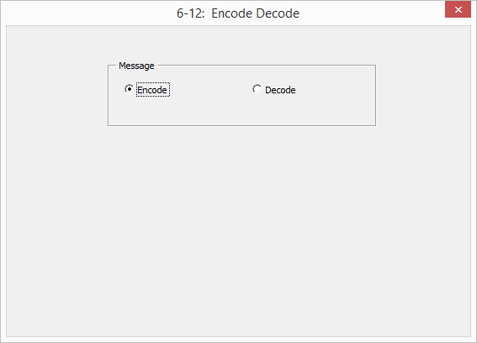

‘Variables
Dim strMessage as string ‘input message
Dim I as single ‘looping variable
Dim strEncodedMsg as string ‘encoded message
Dim sglASC as single ‘stores the ASCII code for a letter
Dim strASC as string ‘sglASC converted to a string

‘INPUT
‘get strMessage from an inputbox

‘Calculation
‘Convert each letter of strMessage to it’s corresponding ‘ASCII Code
- Use ASC to convert the current letter in strMessage to its ASCII code and store in sglASC
- Convert sglASC to a string and store in strASC
- Concatenate strASC to strEncodedMsg (update strEncodedMsg
Repeat (a) – (c) for all of the letters in strMessage

‘Output
Output strEncodedMsg onto the label

